- 제목

ZEESOON Korean BBQ Pre-seasoned Grill Pan 13inches Non-Stick 6 Layer Coating Round Griddle Stovetop, Indoor & Outdoor, Including Tong, Bag and 2 of silicon holders

- 가격
- BBQ 그릴 : 22150원 / 1160g
- 악어 집계 : 1400원 / 77g
- 냄비 손잡이 : 960원 x 2pcs = 1920 원 / 67g x 2pcs = 134g
합계 : 25470 원 / 1371g (배송비 1371g x 9원 = 12339원) 총계 37,809원
FBA 수수료 : 5.68
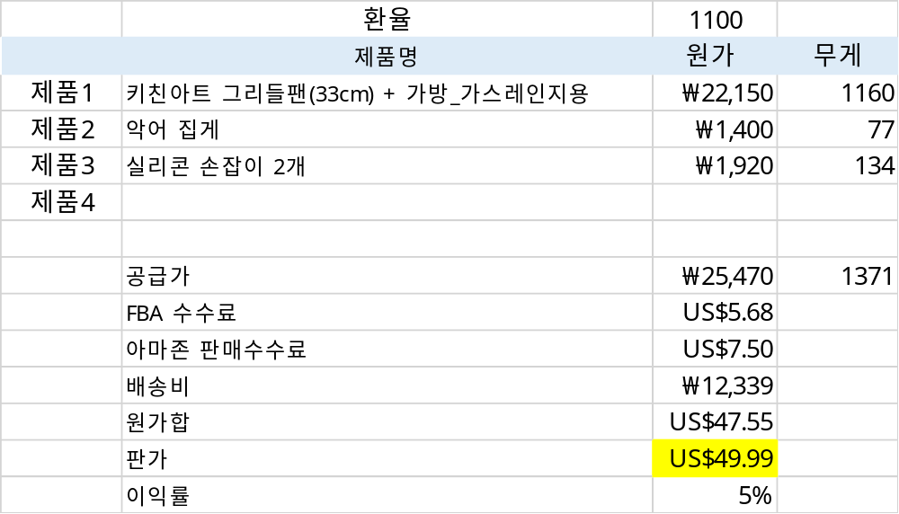
- Bulletin board 부분

- ZEESOON Korean BBQ Grill Pan has Non-stick 6 Layer Coating and can be used on top of Stovetop, camping burner. So can be used in indoor and outdoor.
Coated with non-stick coating technique, it is safe and healthy that doesn't generate harmful ingredients compounds(PFOA, etc.).
- ONE STOP PACKAGE – Including 1 of carrying bag, 9.4 inches tongs and 2 of silicon handle holders, so it is easy to carry and pack for camping or traveling
- HIGH QUALITY - It is made of round casting using aluminum die casting method, which is a precision metal processing technology, and has the advantage of excellent thermal conductivity, dense material structure and excellent composition.
- COMPATIBLE WITH ALL HEAT SOURCES - Use this grill pan on any cooktop including induction, gas range, electronic range, and hot plate., so you can enjoy grilled steak, bacon, pork belly, pork chops, sausage, seafoods, vegetables, and more.
- KEEP SAFE - Removable pot handle cover wrap easily onto hot frying pan and pot hand to block heat and enhanced grip with grain on the handle, provide you more protection
- DIMENSION - Inner Diameter: 13inches / 33cm, Including Outer Handle: 15.7inches / 40cm , Tong : 9.4inches / 24cm, Silicon Handler : 3inches / 8cm (Random Color)

- Description 부분
A+ Contents 로 정리
- Search Keyword
: Korea grill pan bbq outdoor camping kitchen

- 성분

A+ Contents 는 하기와 같이 구성하세요
Main Features
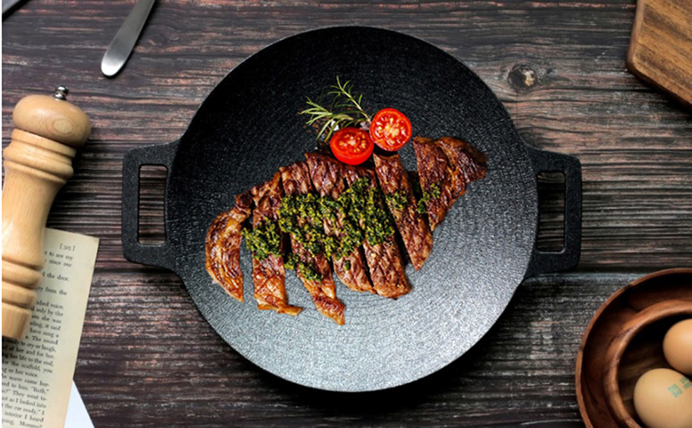

Luxury design and excellent 6 layers non stick coating! No need seasoning!
Including carry bag, metal tongs and silicon hander
It can be used for various purposes, from grilled dishes to stir-fried dishes to hotpot dishes.
It is “Must Have” item for camping and outdoor barbecue parties

6-Layer Non stick coating
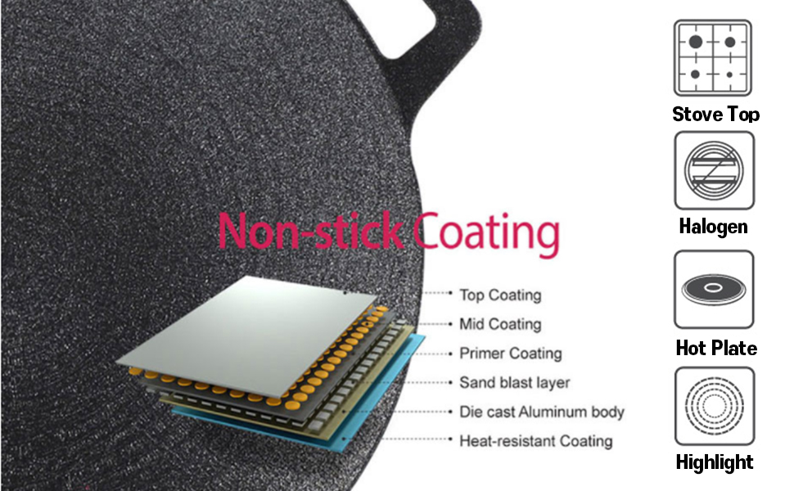

The 6-layer non-stick coating prevents food from sticking and is easy to clean
(Top coating, Mild coating, Primer Coating, Sand blast layer, Die cast aluminum body, Heat-resistant coating)
It can be used in various heat sources such as gas stove, halogen, hot plate, and highlight.
(IH induction cannot be used)

Strong Aluminum whole casting method
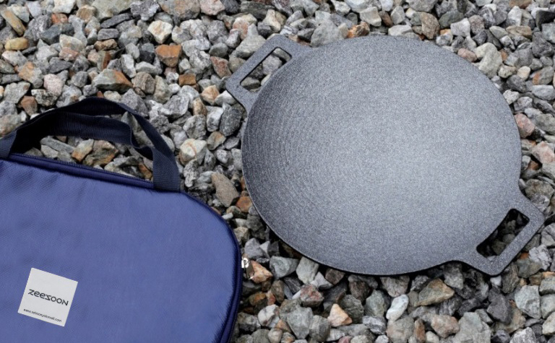

It made by aluminum whole casting method, very strong for damage from outside and supplies excellent heat retention and thermal conductivity
It perfectly digests various food preparations as well as plating.

All in one package
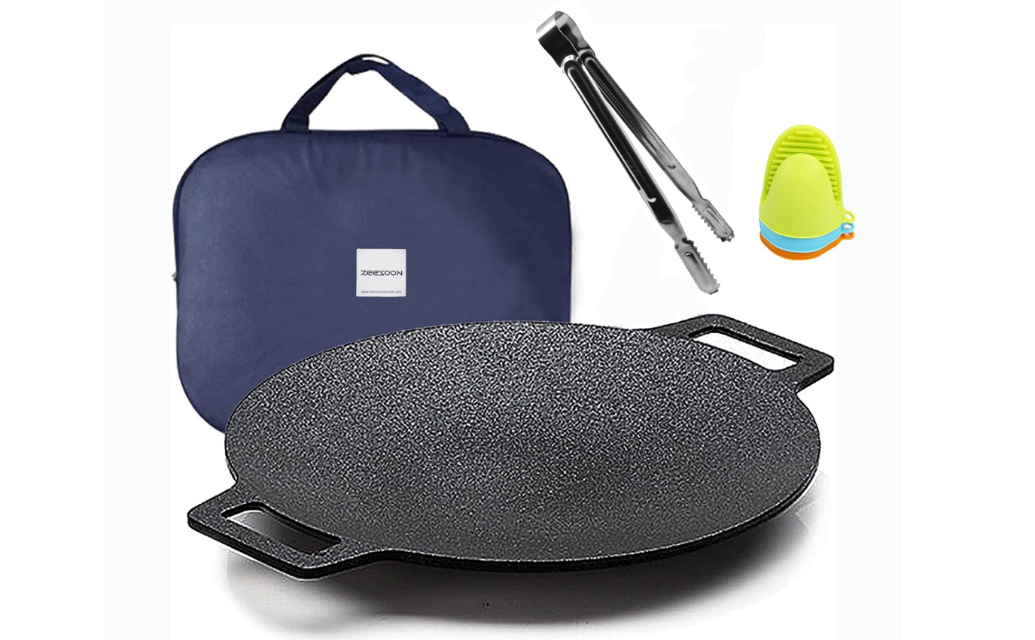
One bag contains the tools you need for cooking, making it easy to transport and store.
Light weight and convenient to carry.
Components and Dimension
Grill pan : Inner Diameter (13 Inches) -> 33Cm / Outer Handle (15.7 Inches) -> 40Cm
Metal tong : Tong : 9.4inches / 24cm,
Silicon Handler : 3inches / 8cm (Random Color 2pcs)
Origin : Korea

